

Bachelor of Computer Applications(BCA)

Web Designing Journal

BCA Sem IV

AY 2018-19

*<Topic Title: Online Gift Shop>*

*by*

|  |  |  |
| --- | --- | --- |
| Exam No. | Roll No. | Name of Student |
| 2861 | 72 | Vivek Ghetiya |

**INDEX**

|  |  |  |  |
| --- | --- | --- | --- |
| **No** | **Description** | **Page No** | **Sign** |
| 1 | Introduction | 3 |  |
| 2 | Home Page Screenshot | 4 |  |
| 3 | Home Page Code | 5-9 |  |
| 4 | About page Screenshot | 10 |  |
| 5 | About Page Code | 11-13 |  |
| 6 | Gallary Page Screenshot | 14 |  |
| 7 | Gallary Page Code | 15-17 |  |
| 8 | Register Page Screenshot | 18 |  |
| 9 | Register Page Code | 19-21 |  |
| 10 | Log In Page Screen Shot | 22 |  |
| 11 | Log In Page Code | 23 |  |
| 12 | Contact page Screenshot | 24 |  |
| 13 | Contact page Code | 25-26 |  |
| 14 | CSS Code | 27-38 |  |

**Introduction about Website**

Our Web site is here to provide deferent types of gift which have deferent verayti. Our gift products are prices is low in that all other.

We believe in to make happy customer and they are trust in our shop. We deliver order in fastest as soon as possible and delivery charges are also lowest.

This is basically only information provides about the goods and its material details .in this website the customer can reach to this website and see the new products that are uploaded by the owner

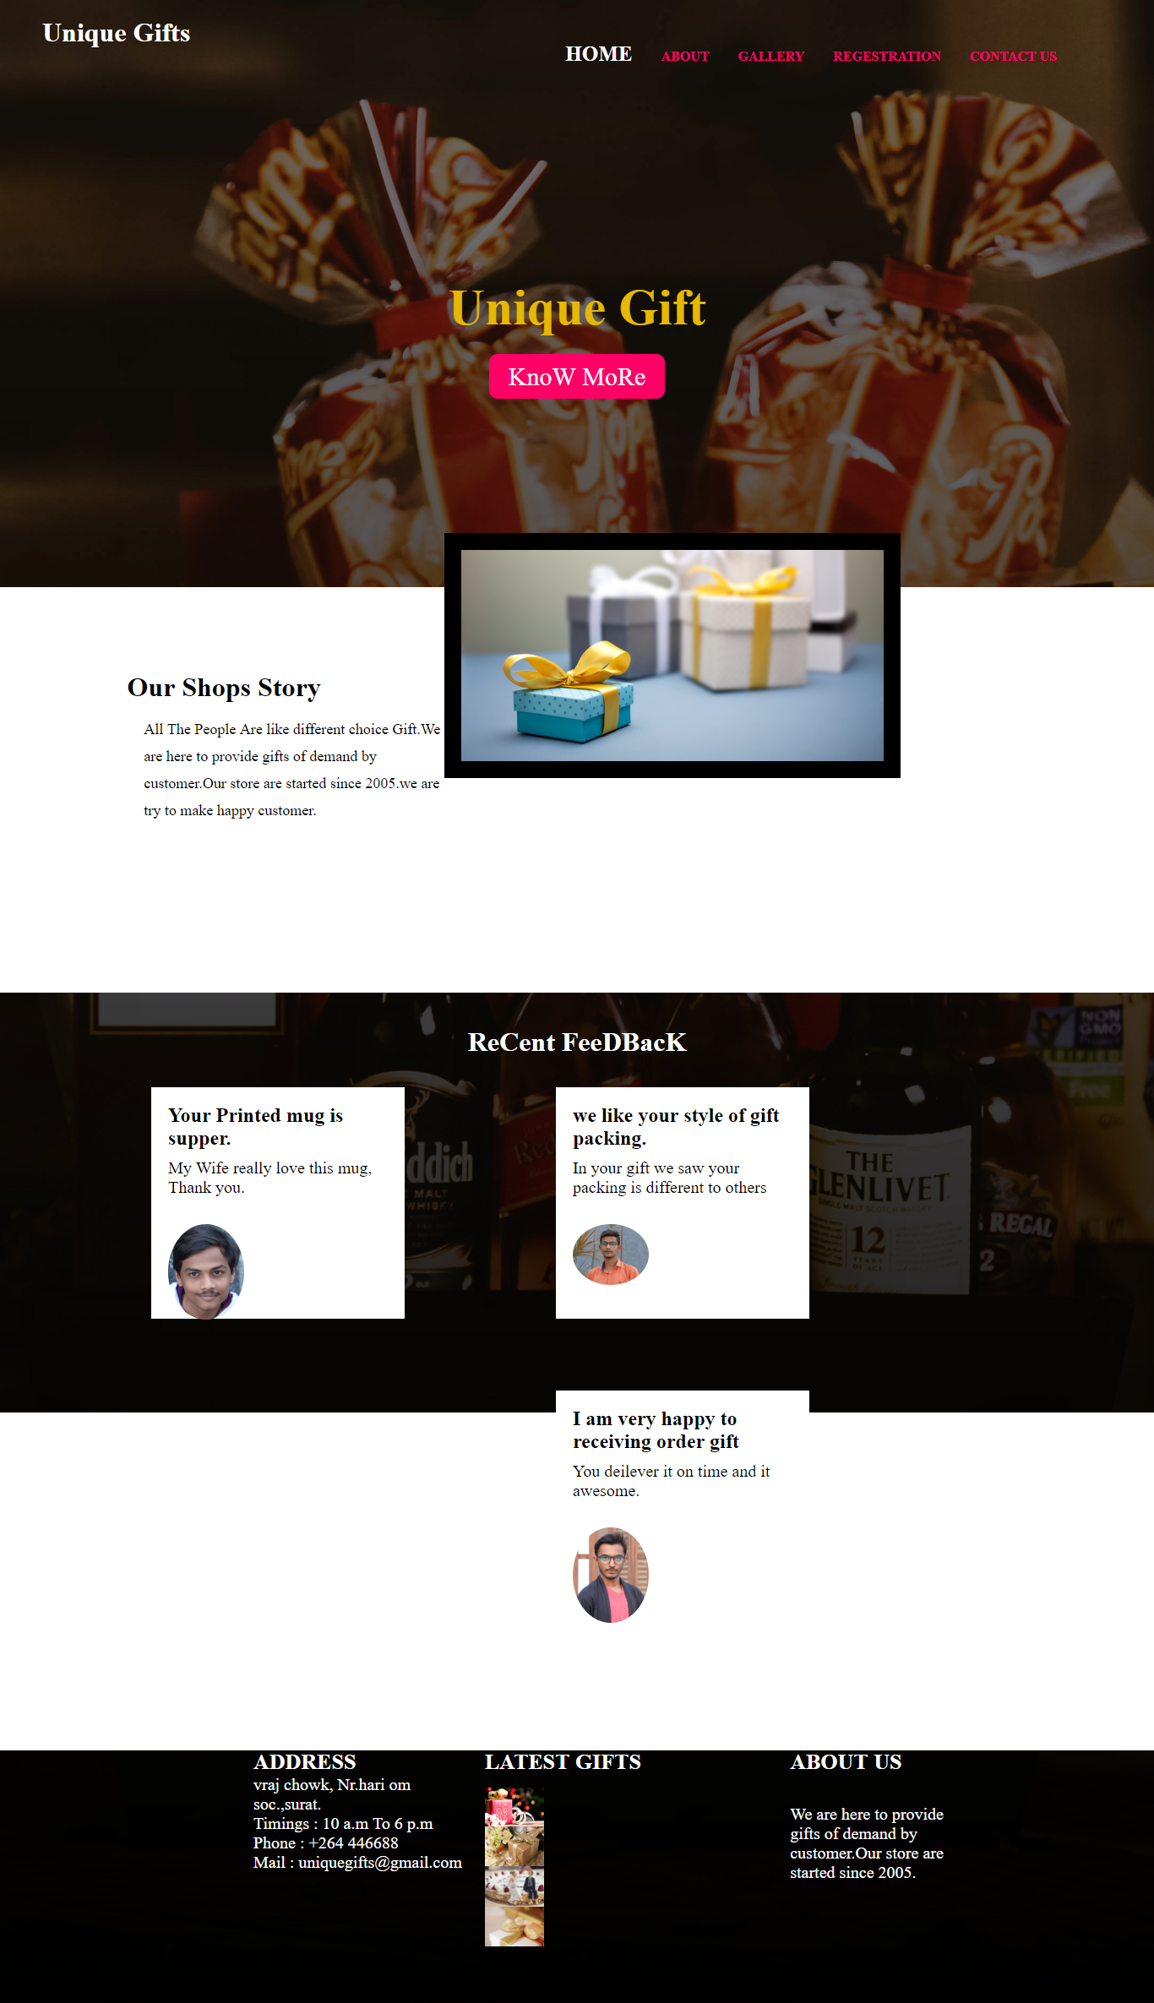

**Code:**

**<html>**

**<head>**

**<title>**

**Online Gift Sale**

**</title>**

**<link rel="stylesheet" type="text/css" href="css.css">**

**</head>**

**<body>**

**<header>**

**<div class="logo">**

**<h1>Unique Gifts**

**</h1>**

**</div>**

**<ul>**

**<li>**

**<a class="home" href="html.html">HOME</a>**

**<a href="about.html">ABOUT</a>**

**<a href="gallery.html">GALLERY</a>**

**</li>**

**<li class="dropdown"><a class="dropbtn" href="#">REGESTRATION</a>**

**<div class="droplist">**

**<a href="Regestration.html">Regestration</a>**

**<a href="login.html">Log In</a>**

**</div>**

**</li>**

**<li>**

**<a href="contact.html">CONTACT US</a>**

**</li>**

**</ul>**

**</header>**

**<div class="banner">**

**<h1>Unique Gift</h1>**

**<a href="#">KnoW MoRe</a>**

**</div>**

**<div class="story"><img src="bg4.jpg" class="storyimg">**

**<h1>Our Shops Story</h1>**

**<p>All The People Are like different choice Gift.We are here to provide gifts of demand by customer.Our store are started since 2005.we are try to make happy customer.</p>**

**</div>**

**<div class="feedback">**

**<h1>ReCent FeeDBacK</h1>**

**<div>**

**<div class="feed">**

**<h2>Your Printed mug is supper.</h2>**

**<p>My Wife really love this mug, Thank you.</p>**

**<img src=fed1.jpg>**

**</div>**

**<div class="feed">**

**<h2>we like your style of gift packing.</h2>**

**<p>In your gift we saw your packing is different to others</p>**

**<img src=fed2.jpg>**

**</div>**

**<div class="feed">**

**<h2>I am very happy to receiving order gift</h2>**

**<p>You deilever it on time and it awesome.</p>**

**<img src=fed3.jpg>**

**</div>**

**</div>**

**</div>**

**<footer>**

**<div class="footer">**

**<div class="address">**

**<h1>ADDRESS</h1><br><br>**

**<p>vraj chowk, Nr.hari om soc.,surat.</p>**

**<p>Timings : 10 a.m To 6 p.m</p>**

**<p>Phone : +264 446688</p>**

**<p>Mail : uniquegifts@gmail.com</p>**

**</div>**

**<div class="events">**

**<h1>LATEST GIFTS</h1>**

**<div class="eventimg">**

**<a href="eve1.jpg"><img src=eve1.jpg></a>**

**<a href="eve2.jpg"><img src=eve2.jpg></a>**

**<a href="eve3.jpg"><img src=eve3.jpg></a>**

**<a href="eve4.jpg"><img src=eve4.jpg></a>**

**</div>**

**</div>**

**<div class="about">**

**<h1>ABOUT US</h1>**

**<p>We are here to provide gifts of demand by customer.Our store are started since 2005.</p>**

**</div>**

**</div>**

**</footer>**

**</body>**

**</html>**

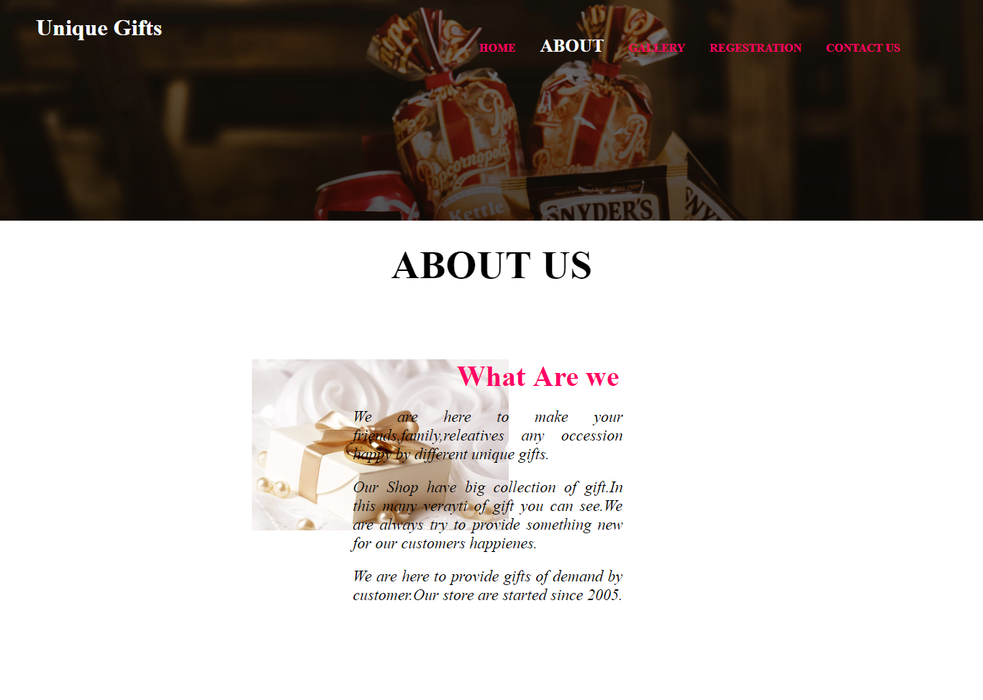

**Code:**

**<html>**

**<head>**

**<title>**

**Online Gift Sale**

**</title>**

**<link rel="stylesheet" type="text/css" href="css.css">**

**</head>**

**<body>**

**<header>**

**<div class="logo">**

**<h1>Unique Gifts</h1>**

**</div>**

**<ul>**

**<li>**

**<a href="html.html">HOME</a>**

**<a class="aboutbtn"href="about.html">ABOUT</a>**

**<a href="gallery.html">GALLERY</a>**

**</li>**

**<li class="dropdown"><a class="dropbtn" href="#">REGESTRATION</a>**

**<div class="droplist">**

**<a href="Regestration.html">Regestration</a>**

**<a href="login.html">Log In</a>**

**</div>**

**</li>**

**<li>**

**<a href="contactus.html">CONTACT US</a>**

**</li>**

**</ul>**

**</header>**

**<div class="aboutus">**

**<div class="title">**

**<h1>ABOUT US</h1>**

**</div>**

**<div class="aboutimg">**

**<img src=abt.jpg>**

**</div>**

**<div class="aboutdesc">**

**<h1>What Are we</h1><br>**

**<p>We are here to make your friends,family,releatives any occession happy by different unique gifts.</p><br>**

**<p>Our Shop have big collection of gift.In this many verayti of gift you can see.We are always try to provide something new for our customers happienes.</p>**

**<p>We are here to provide gifts of demand by customer.Our store are started since 2005.**

**</p>**

**</div>**

**</div>**

**</body>**

**</html>**

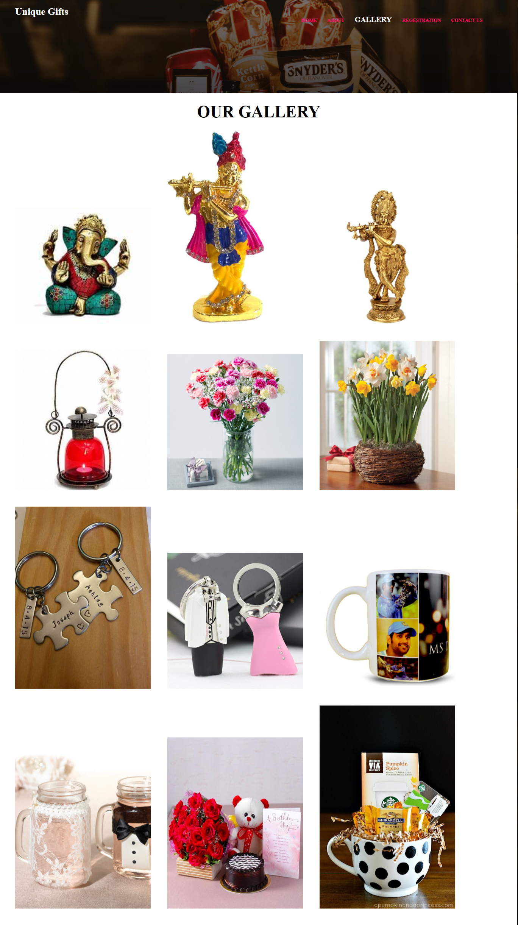

**Code:**

**<html>**

**<head>**

**<title>**

**Online Gift Saler**

**</title>**

**<link rel="stylesheet" type="text/css" href="css.css">**

**</head>**

**<body>**

**<header>**

**<div class="logo">**

**<h1>Unique Gifts</h1>**

**</div>**

**<ul>**

**<li>**

**<a href="html.html">HOME</a>**

**<a href="about.html">ABOUT</a>**

**<a class="gallerybtn" href="gallery.html">GALLERY</a>**

**</li>**

**<li class="dropdown"><a class="dropbtn" href="#">REGESTRATION</a>**

**<div class="droplist">**

**<a href="Regestration.html">Regestration</a>**

**<a href="login.html">Log In</a>**

**</div>**

**</li>**

**<li>**

**<a href="contact.html">CONTACT US</a>**

**</li>**

**</ul>**

**</header>**

**<body>**

**<div class="gallery">**

**<div class="gallerytitle">**

**<h1>OUR GALLERY</h1>**

**</div>**

**<div class="galleryimg">**

**<a href="gift1.jpg"><img src=gift1.jpg></a>**

**<a href="gift2.jpg"><img src=gift2.jpg></a>**

**<a href="gift3.jpg"><img src=gift3.jpg></a>**

**<a href="gift4.jpg"><img src=gift4.jpg></a>**

**<a href="gift5.jpg"><img src=gift5.jpg></a>**

**<a href="gift6.jpg"><img src=gift6.jpg></a>**

**<a href="gift7.jpg"><img src=gift7.jpg></a>**

**<a href="gift8.jpg"><img src=gift8.jpg></a>**

**<a href="gift9.jpg"><img src=gift9.jpg></a>**

**<a href="gift10.jpg"><img src=gift10.jpg></a>**

**<a href="gift11.jpg"><img src=gift11.jpg></a>**

**<a href="gift12.jpg"><img src=gift12.jpg></a>**

**</div>**

**</div>**

**</body>**

**</html>**

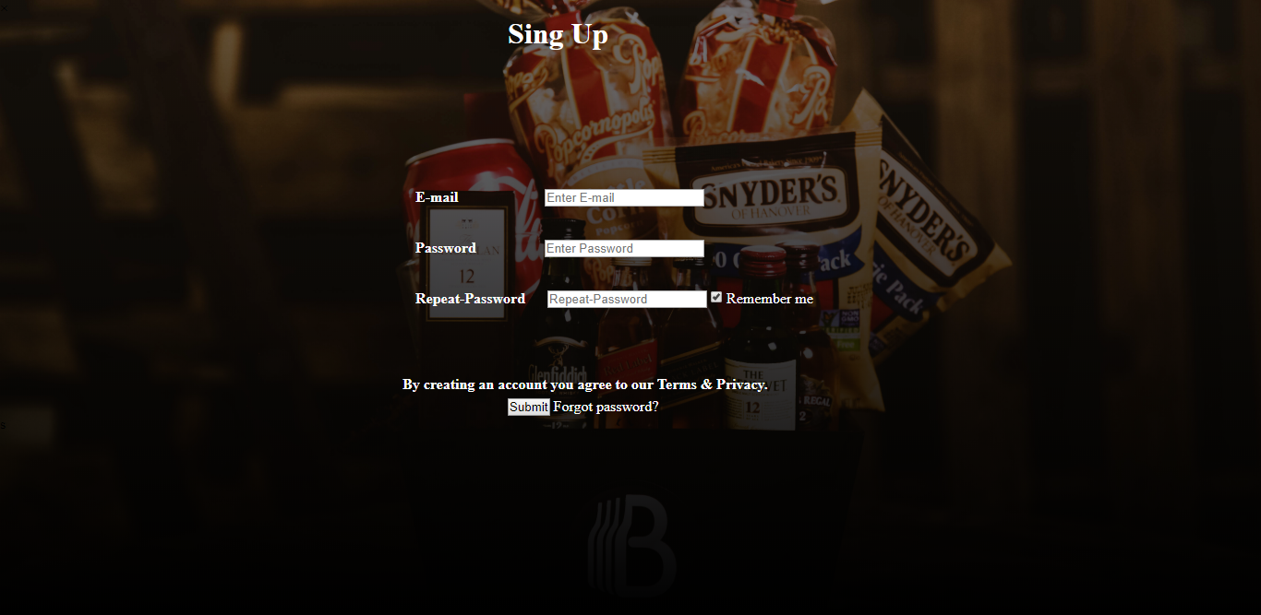

**Code:**

**<html>**

**<head>**

**<title>**

**Online Gift Sale**

**</title>**

**<link rel="stylesheet" type="text/css" href="css.css">**

**</head>**

**<body>**

**<div id="id02" class="modal">**

**<form class="modal-content animate" action="/action_page.html">**

**<div class="imgcontainer">**

**<span onclick="document.getElementById('id02').style.display='none'" class="close" title="Close Modal">&times;**

**</span>**

**<h1 class="sign">Sing Up</h1>**

**</div>**

**<div class="container">**

**<label for="uname"><b>E-mail</b></label>**

**<input class="regname" type="text" placeholder="Enter E-mail" name="uname" required>**

**<br><br><br>**

**<label for="psw"><b>Password</b></label>**

**<input class="regpass" type="password" placeholder="Enter Password" name="psw" required>**

**<br><br><br>**

**<label for="psw"><b>Repeat-Password</b></label>**

**<input class="regrepass" type="password" placeholder="Repeat-Password" name="psw" required>**

**<label>**

**<input type="checkbox" checked="checked" name="remember"> Remember me**

**</label>**

**<br><br>**

**</div>**

**<h4 class="regnot" style="padding: 6px;"> By creating an account you agree to our Terms & Privacy.</h4>**

**<div>**

**<button class="regbtn" type="submit" class="cancelbtn">Submit</button>**

**<span class="psw">Forgot password?</span>**

**</div>**

**</form>**

**</div>**

**</body>**

**</html>**

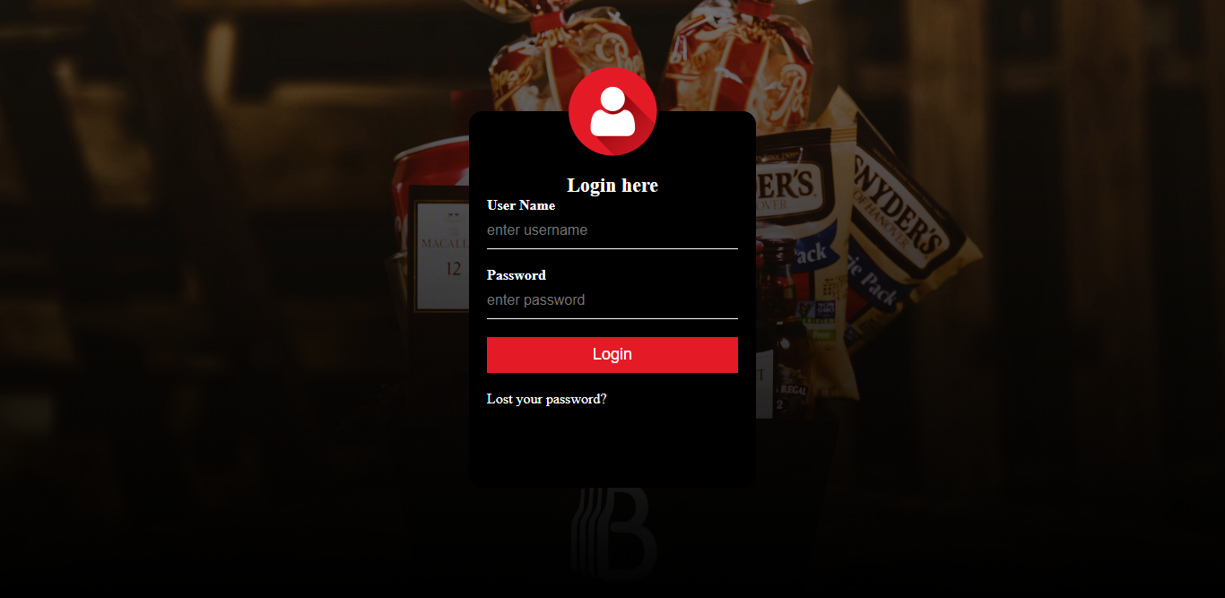

**Code:**

**<html>**

**<head>**

**<title>**

**Online Gift Saler**

**</title>**

**<link rel="stylesheet" type="text/css" href="css.css">**

**</head>**

**<body>**

**<form action="html.html">**

**<div class="loginbox">**

**<img src="login.png" class="loginlogo">**

**<h1 class="login">Login here</h1>**

**<p>User Name</p>**

**<input type="text" name="" placeholder="enter username" required><br>**

**<p>Password</p>**

**<input type="password" name="" placeholder="enter password" required><br>**

**<button id="submit" type="submit">Login</button>**

**<a id="forgot" href="#">Lost your password?</a>**

**</div>**

**</form>**

**</body>**

**</html>**

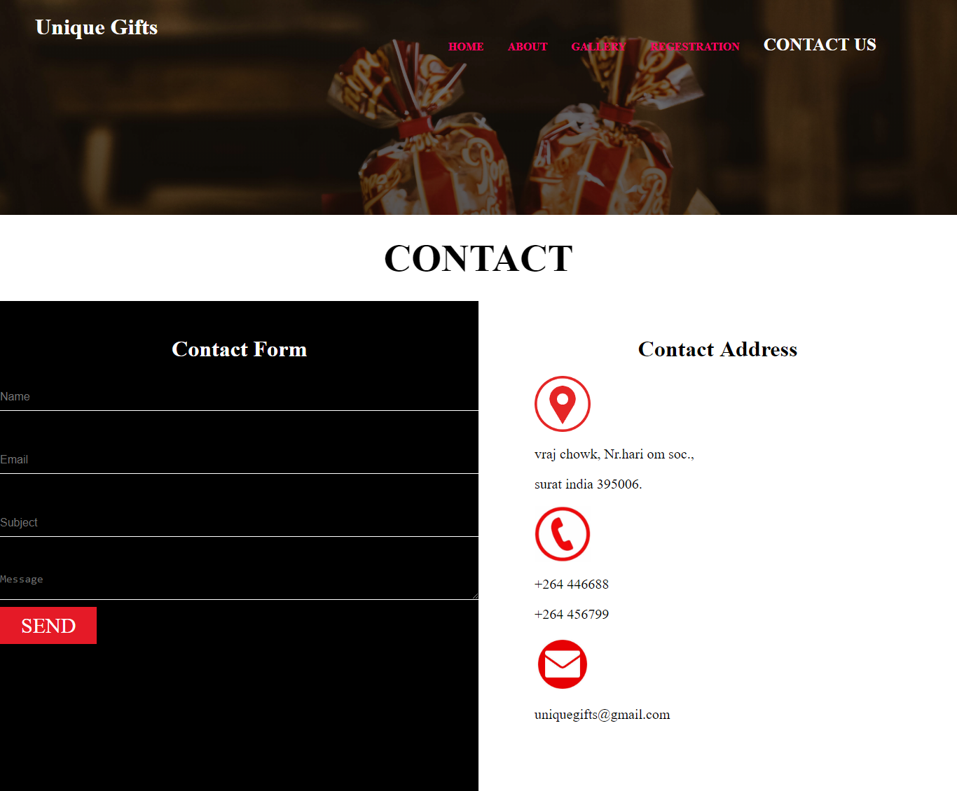

**CODE :**

**<html>**

**<head>**

**<title>**

**Online Gift Sale**

**</title>**

**<link rel="stylesheet" type="text/css" href="css.css">**

**</head>**

**<body>**

**<header>**

**<div class="logo">**

**<h1>**

**Unique Gifts**

**</h1>**

**</div>**

**<ul>**

**<li>**

**<a href="html.html">HOME</a>**

**<a href="about.html">ABOUT</a>**

**<a href="gallery.html">GALLERY</a>**

**</li>**

**<li class="dropdown"><a class="dropbtn" href="#">REGESTRATION</a>**

**<div class="droplist">**

**<a href="Regestration.html">Regestration</a>**

**<a href="login.html">Log In</a>**

**</div>**

**</li>**

**<li>**

**<a class="contactbtn" href="contact.html">CONTACT US</a>**

**</li>**

**</ul>**

**</header>**

**<body>**

**<div class="contactus">**

**<div class="contacttitle">**

**<h1>CONTACT</h1>**

**</div>**

**<div class="contactform">**

**<form action="contact.html">**

**<h1>Contact Form</h1>**

**<input type="text" name="" placeholder="Name" required><br>**

**<input type="text" name="" placeholder="Email" required><br>**

**<input type="text" name="" placeholder="Subject" required><br>**

**<textarea type="textbox" name="" placeholder="Message" required></textarea><br>**

**<a href="contact.html">SEND</a>**

**</form>**

**</div>**

**<div class="contactaddress">**

**<h1>Contact Address</h1>**

**<img src=location.png><br>**

**<p>vraj chowk, Nr.hari om soc.,</p>**

**<p>surat india 395006.</p>**

**<img src=call.png><br>**

**<p>+264 446688</p>**

**<p>+264 456799</p>**

**<img src=mail.png>**

**<p>uniquegifts@gmail.com</p>**

**</div>**

**</div>**

**</body>**

**</html>**

**CSS :**

**\*{**

**margin:0;**

**padding:0;**

**}**

**body{**

**background-image:linear-gradient(rgba(0,0,0,0.5),rgba(0,0,0,1)), url("bg2.jpg");**

**background-size:cover;**

**background-position:center;**

**height:100vh;**

**}**

**.loginbox{**

**width:320px;**

**height:420px;**

**background:#000;**

**color:#fff;**

**top:50%;**

**left:50%;**

**position:absolute;**

**transform:translate(-50%,-50%);**

**box-sizing:border-box;**

**border-radius: 15px;**

**padding: 20px;**

**padding-top: 0;**

**}**

**.loginlogo{**

**width:100px;**

**height:100px;**

**border-radius:50%;**

**position:absolute;**

**transform:translate(-50%,-50%);**

**left:50%;**

**}**

**.login{**

**margin-top:50px;**

**padding-top: 20px;**

**text-align:center;**

**font-size:22px;**

**}**

**.loginbox p{**

**margin:0;**

**padding:0;**

**font-weight:bold;**

**}**

**.loginbox input{**

**width:100%;**

**margin-bottom:20px;**

**}**

**.loginbox input[type="text"],.loginbox input[type="password"]{**

**border:none;**

**border-bottom:1px solid #fff;**

**background:transparent;**

**outline:none;**

**height:40px;**

**color:#fff;**

**font-size:16px;**

**}**

**.loginbox #submit{**

**border:none;**

**outline:none;**

**height:40px;**

**width:100%;**

**margin-bottom: 20px;**

**background:#e51a27 ;**

**font-size:18px;**

**color:#fff;**

**}**

**.loginbox a {**

**text-decoration:none;**

**color: #FFF;**

**}**

**ul{**

**float:right;**

**margin-right:100px;**

**margin-top:50px;**

**}**

**ul li{**

**display:inline-block;**

**}**

**ul li a{**

**text-decoration:none;**

**padding:10px 15px;**

**font-weight:bold;**

**color:#ff0066;**

**}**

**li a:hover{**

**background-color:#ff0066;**

**color:white;**

**transition:0.6s ease;**

**border-radius:10px;**

**}**

**.home{**

**color:white;**

**font-size:25px;**

**}**

**.dropdown:hover .droplist{**

**display:block;**

**}**

**.droplist {**

**display:none;**

**position:absolute;**

**color:#ff0066;**

**}**

**.droplist a:hover{**

**color:black;**

**background-color:white;**

**}**

**.droplist a{**

**display:block;**

**}**

**.logo a{**

**color:white;**

**text-decoration:none;**

**}**

**.logo {**

**display: inline-block;**

**margin-left: 50px;**

**margin-top: 20px;**

**color: white;**

**}**

**.banner{**

**text-align:center;**

**display:block;**

**color:#e6b800;**

**font-size:30px;**

**margin-top:20%;**

**}**

**.banner h1 {**

**margin-bottom: 30px;**

**}**

**.banner a{**

**text-decoration:none;**

**background-color:#ff0066;**

**color:white;**

**border-radius:10px;**

**border:none;**

**padding:10px 23px;**

**transition:1s all;**

**}**

**.story {**

**background-color:white;**

**margin-top:17%;**

**width:100%;**

**padding-bottom:200px;**

**}**

**.story h1, .story p{**

**margin-left: 11%;**

**}**

**.story h1{**

**padding-top:100px;**

**}**

**.story p{**

**max-width: 40%;**

**display: block;**

**font-size: 18px;**

**line-height: 1.8;**

**padding-top:15px;**

**}**

**.storyimg{**

**margin-right:300px;**

**width:500px;**

**height:auto;**

**float:right;**

**margin-top:-4em;**

**border:20px solid black;**

**}**

**.feedback{**

**text-align:center;**

**margin-top:40px;**

**}**

**.feedback h1{**

**color:white;**

**}**

**.feed{**

**margin-top:35px;**

**max-width:300px;**

**margin-left:13.1%;**

**text-align:left;**

**float:left;**

**margin-bottom:50px;**

**}**

**.feed h2{**

**background-color:white;**

**padding-bottom:200px;**

**}**

**.feed p{**

**margin-top:-210px;**

**font-family:Times New Roman;**

**max-width:250px;**

**font-size:20px;**

**float:left;**

**}**

**.feed h2,p{**

**padding-left:20px;**

**padding-top:20px;**

**padding-right:20px;**

**}**

**.feed img{**

**margin-top:-7em;**

**margin-left:20px;**

**vertical-align:middle;**

**border-radius:50%;**

**height:auto;**

**max-width:30%;**

**}**

**.footer{**

**width:100%;**

**height:400px;**

**background:#fff;**

**margin-top:420px;**

**}**

**.address{**

**width:42%;**

**height:100%;**

**float:left;**

**}**

**.address h1{**

**float:left;**

**margin-top:100px;**

**margin-right: 50%;**

**margin-left: 300px;**

**font-size: 26px;**

**color: white;**

**}**

**.address p{**

**margin-left:280px;**

**font-size: 20px;**

**margin-top: -20px;**

**color:white;**

**}**

**.events{**

**width:25%;**

**height:100%;**

**float:left;**

**}**

**.events h1{**

**float:left;**

**margin-top:100px;**

**font-size: 26px;**

**margin-bottom: 15px;**

**color:white;**

**}**

**.events .eventimg{**

**margin-right:200px;**

**display: inline;**

**float: left;**

**color: white;**

**}**

**.events .eventimg img{**

**width:50%;**

**height:auto;**

**}**

**.about{**

**width:25%;**

**height:100%;**

**float:left;**

**color: white;**

**}**

**.about h1{**

**float:left;**

**margin-top:100px;**

**font-size: 26px;**

**margin-bottom: 15px;**

**margin-left: 20px;**

**}**

**.about p{**

**width: 65%;**

**font-size: 20px;**

**float: left;**

**}**

**.aboutbtn{**

**color: white;**

**font-size: 25px;**

**}**

**.aboutus{**

**width: 100%;**

**height: 100%;**

**margin-top: 250px;**

**background-color: white;**

**}**

**.title{**

**width:100%;**

**height:auto;**

**}**

**.title h1{**

**text-align:center;**

**color: black;**

**font-size:55px;**

**padding:30px;**

**}**

**.aboutimg{**

**width:45%;**

**height:auto;**

**float:left;**

**}**

**.aboutus img{**

**width:58%;**

**float:left;**

**margin-left:350px;**

**margin-top:70px;**

**}**

**.aboutdesc{**

**width:55%;**

**height:auto;**

**float:left;**

**}**

**.aboutdesc h1{**

**float:left;**

**margin-top:70px;**

**margin-left:20px;**

**color:#ff0066;**

**font-size:40px;**

**}**

**.aboutdesc p{**

**float: right;**

**margin-top: 0;**

**font-size: 22px;**

**width: 50%;**

**margin-right: 480px;**

**text-align: justify;**

**color: black;**

**font-style:italic;**

**}**

**.gallerybtn{**

**color: white;**

**font-size: 25px;**

**}**

**.gallery{**

**width: 100%;**

**height: auto;**

**margin-top: 250px;**

**background-color: white;**

**}**

**.gallerytitle{**

**width:100%;**

**height:auto;**

**}**

**.gallerytitle h1{**

**text-align:center;**

**color: black;**

**font-size:55px;**

**padding:30px;**

**}**

**.galleryimg{**

**width:105%;**

**height:auto;**

**}**

**.galleryimg img{**

**width: 25%;**

**margin-left: 50px;**

**margin-bottom:50px;**

**}**

**.contactbtn{**

**color: white;**

**font-size: 25px;**

**}**

**.contactus{**

**width: 100%;**

**height: auto;**

**margin-top: 250px;**

**background-color: white;**

**}**

**.contacttitle{**

**width:100%;**

**height:auto;**

**}**

**.contacttitle h1{**

**text-align:center;**

**color: black;**

**font-size:55px;**

**padding:30px;**

**}**

**.contactform{**

**width:50%;**

**height:700px;**

**float:left;**

**background:black;**

**}**

**.contactform h1{**

**color:white;**

**text-align:center;**

**margin-top:50px;**

**}**

**.contactform input, .contactform textarea{**

**width:100%;**

**margin-top:30px;**

**}**

**.contactform input[type="text"],.contactform input[type="text"],.contactform textarea{**

**border:none;**

**border-bottom:1px solid #fff;**

**background:transparent;**

**outline:none;**

**height:40px;**

**color:#fff;**

**font-size:16px;**

**margin-bottom: 20px;**

**}**

**.contactform a{**

**text-decoration:none;**

**padding:10 30 10 30;**

**background:#e51a27 ;**

**font-size:30px;**

**color:#fff;**

**}**

**.contactaddress{**

**width:50%;**

**height:700px;**

**float:right;**

**background:white;**

**}**

**.contactaddress h1{**

**text-align:center;**

**margin-top:50px;**

**}**

**.contactaddress img{**

**width:80px;**

**height:auto;**

**margin-left:80px;**

**margin-top:20px;**

**}**

**.contactaddress p{**

**margin-left:60px;**

**font-size:20px;**

**}**

**.container{**

**color: white;**

**margin-top: 150px;**

**margin-left: 450px;**

**}**

**.sign{**

**color: white;**

**margin-left: 550px;**

**}**

**.regnot{**

**color: white;**

**margin-top: 50px;**

**margin-left: 430px;**

**}**

**.regbtn{**

**margin-left: 550px;**

**}**

**.psw{**

**color: white;**

**}**

**.regname{**

**margin-left: 90px;**

**}**

**.regpass{**

**margin-left: 70px;**

**}**

**.regrepass{**

**margin-left: 20px;**

**}**